Jack Johnson

September 8, 2021

Phase End Project: Chatlog

Link to my GitHub repository: <https://github.com/jjohn98/2058519_Jack_Johnson_Mean_Stack>

This project is located in ~/Phase3/Chatlog.

In this project, I modified my Chatting with Socket IO project to log the messages in MongoDB instead of sending responses from the server. I simply connected to the MongoDB server and used the database “chatlog” and the collection “recieved”. I just insert each message into the MongoDB collection when it is received.

The files for this project will be in the GitHub repository, as well as the source code section of the submission on Simplilearn.

Screenshots of Webpage functionality:

**Before sending a message:**

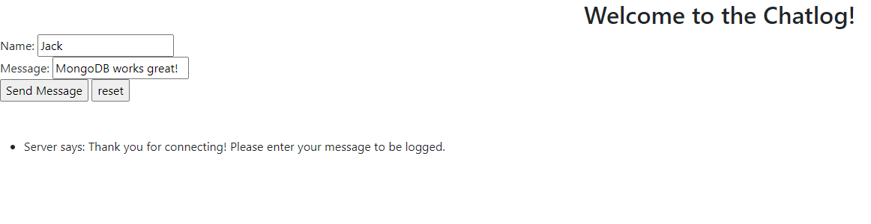

**After sending a message:**

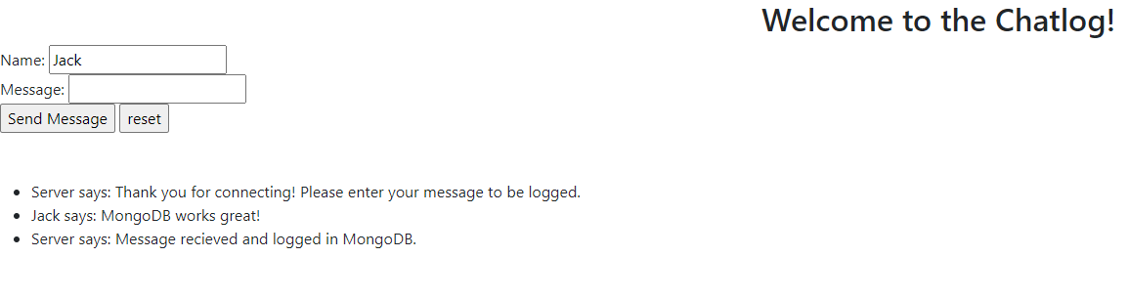

**MongoDB verification:**

